MOBILE COMPUTING
LAB EXPERIMENT 11

11. Design a wireframe for a mobile application that incorporates security measures using Figma
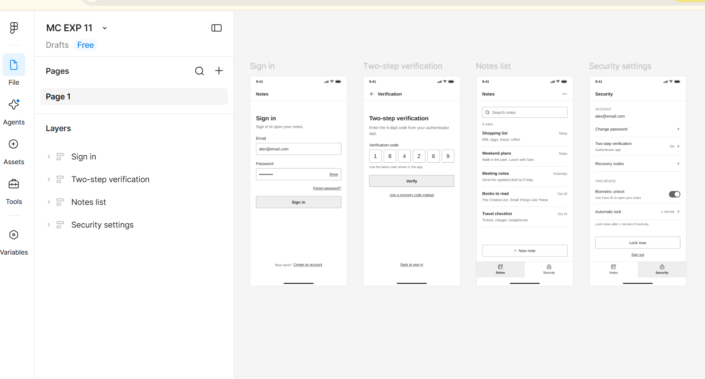

https://www.figma.com/design/FpyXedpen09NiXYHoNjXo6/MC-EXP-11?node-id=0-1&t=qCJbJTVoPlH0izCP-1

